MAINTAIN AND ENHANCE COMMUNITY CHARACTER
7

Overview
Community character is consistently cited as one of the attributes which makes Simsbury special to residents. Maintaining and enhancing community character is an over‐arching principle of this POCD.

Sense of Place Sense of Time
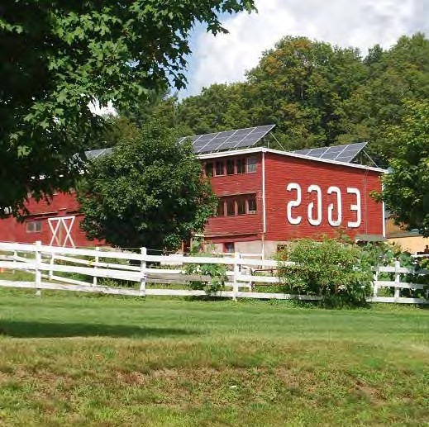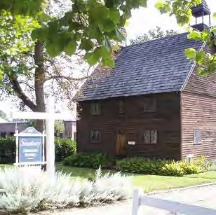

Community Amenities Community Events
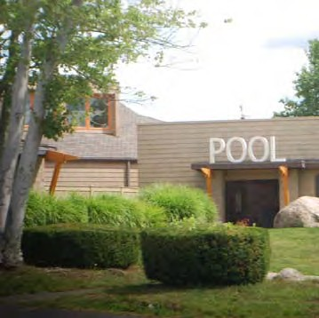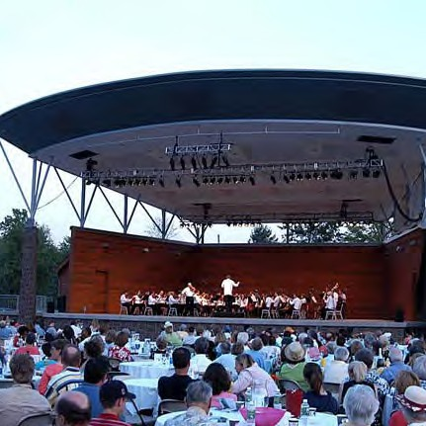

“Sense of Place”

The concept of “place” is abstract, and defining it is elusive; however, you know it when you see it.

Place is found in the organizational patterns of the physical landscape, natural or built, i.e., ridgelines, signature brownstone buildings, winding secondary roads, etc., or in preserved historical land uses, such as farms, factories, mills, etc.

These patterns extend be‐ yond the visual. It is more than just the way the town “looks”.

“Place” is also manifested in the interaction between human and habitat. The organizational pattern of a farmstead, for example, includes the familiar house, barns and fields. But it also includes the experience of a farm—the sounds (livestock and tractors), the smells (manure and freshly mown hay), and the history associated with the site (perhaps owned by the same family for generations or renowned for its organic produce).

Some of the attributes that contribute to community character in Simsbury include:
- Natural resources such as the topography of Talcott and the West Mountains and the Farmington River
- Open space resources
- Scenic views, scenic roads, and other scenic resources including views of the ridgelines, hillsides, and the river valley
- Farms and farming
- Historic buildings and sites
- Settlement patterns such as villages and other unique places
- Community services and facilities (such as schools and other Town services)
- Community amenities (such as the Farmington Canal Heritage Trail and Simsbury Farms)
- Community events (such as events at the Performing Arts Center)

A listing of some recognized character resources is contained on the following pages.

Yet, in reality, community character is not just any one of these things. It is the totality of all of these things. Simsbury has a “sense of place” because these elements (and many others) are all interwoven into the fabric of the community.

This “sense of place” is part of what draws people to Simsbury. People make a conscious choice to live here or visit here or stay here because of its small town character and sense of community and all of the elements that contribute to character.

Heublein Tower Fountain in Weatogue Town Clock

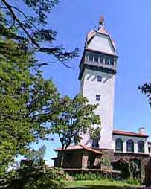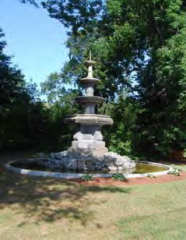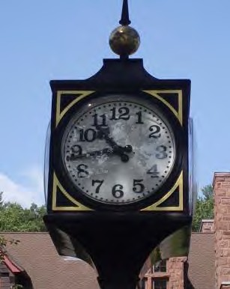

Listing of Some Current And Former Character Resources

Buildings
  - Joseph Ensign House (corner of Drake Hill Road)
  - Simsburytown Shops – example of village style/scale center
  - Former Ensign Bickford complex
  - Railroad station buildings
  - Former Tobacco Barns on Route 10
  - Central School
  - Town Offices (Belden School)
  - Hop Brook Mill / Brownstone Building

Aesthetic Places
- Hop Brook waterfall
- King Philip’s Cave
- Massaco Plantation
- Militia Training Band Field
- Sycamores along Route 10
- Hillsides, ridgelines and escarpments
- The Farmington River flood plain
- Stone walls
- Bartlett Tower
- Sugarloaf Mountain
- Patterson Park
- Simsbury Meadows
- Case Meadow Ethel Walker Woods
- Simsbury Center
- Garrett stairs at McLean Game Refuge
- Heublein Tower
- Intersection of Laurel Ln / Great Pond
- Drake Hill Bridge
- Farmington Canal Heritage Trail
- Farmington River Canal
- Fields across Route 10 from Blue Ridge
/ Lincoln / Old Meadow Plain
- Fountain in Weatogue

- Tobacco Fields / Barns / Dormitory
- The Tariffville Mill
- Former Pettibone’s Tavern (Abigail’s)
- St. Mary’s Church
- Methodist Church
- Congregational Church
- St. Bernard’s Church
- Trinity Episcopal Church
- “Courtyard Building”

- Silo and Sycamore at Folly Farm
- Pinchot Sycamore tree
- Old quarry
- Route 185 Bridge
- Waterfall at McLean Game Refuge
- West Simsbury Center
- Barndoor Hills view
- Grave site on East Weatogue Street (ox cart death)
- Tobacco fields / barns: Firetown Road, Hoskins
- Old barn on Terry’s Plain Road, for‐ merly Bartlett Farm
- Scenic road along East Weatogue Street, Terry’s Plain Road, Ferry Lane
- Views of the Farmington River along Riverside Road, Terry’s Plain Road
- Nod Brook field
- Public school properties (see details on Community Facilities Plan)
- Simsbury Farms recreation complex
- Private school properties (such as Westminster, Ethel Walker, Masters)

In the telephone survey, participants were asked whether they agreed or disagreed with the following statements:

Simsbury should try to encourage more public events, such as concerts, festivals and other family‐friendly events.

Strongly agree 24%
Agree | 55%
Not sure | 5%
Disagree | 15%
Strongly disagree | 1%

Does Simsbury offer enough entertainment options (mu‐ sic, movies, plays, etc.)?

Too many | 1%
About right | 49%
Too few | 48%
Not sure | 2%

Community Events
  - Talcott Mountain Music Festival (Hart‐ ford Symphony)
  - Performing Arts Center
  - Septemberfest
  - Simsbury Light Opera
  - Simsbury Summer Theater For Youth

  - Simsbury Fly‐In
  - Simsbury Celebrates (First Night)
  - Luminary Night
  - Memorial Day Parade
  - River Run
  - Simsbury Bike Month (May)

(continued on next page)

Volunteer Efforts

Listing of Some Current And Former Character Resources (continued)

Historic Districts Farms
- East Weatogue Historic District 1. Tulmeadow Farm
- Terry’s Plain Historic District 2. Flamig Farm
- Tariffville Historic District 3. George Hall Farm
- Simsbury Center Historic District 4. Joseph Hall Farm
- Rosedale Farm
- Pickin’ Patch Farm
- Town Farm
- Folly Farm
- Ryan’s Flower Farm
- Anthony’s Farm

Watercourses / Waterbodies Parks and Recreation
- Farmington River 1. Town Forest
- Meadow Pond 2. Stratton Brook Park
- Tariffville Gorge 3. Schultz Park
- Great Pond 4. Tariffville Park
- Streams and brooks 5. Tariffville Green
- Ponds 6. State Wildlife Management Area
- McLean Game Refuge
- Metacomet Trail
- Curtiss Park
- Memorial Park
- Hopmeadow Country Club
- Tower Ridge Country Club
- Onion Mountain Park
- Belden Forest
- Talcott Mountain State Park
- Penwood State Park
- Metacomet Trail overlook
- The Hedgehog
- The Sugarloaf

The importance placed on community character is pervasive in the community and supported by many local organizations.

For example, volunteers associated with the Beautification Committee maintain more than 60 flower gardens and planters on Town land throughout Simsbury including:
- Schultz Park
- Town Hall
- Simsbury Public Library
- Simsbury Farms recreation complex
- Welcome signs and brownstone pillars at gateways
- At various islands, inter‐ sections and triangles throughout town
- Eno Memorial Hall
- Entrance to the Flower Bridge
- Key corners

Gateway Signage Schultz Park Rotary Park
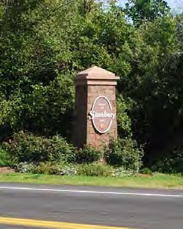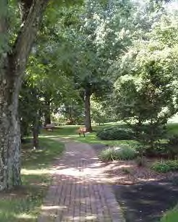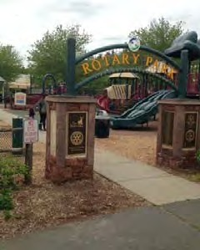

Granby

Character Places

Simsbury, CT

15 East Granby
$
2
6
7 4

7
10
30 28

(!202

15 16

5!(18910

9 9 (!315
5
30
30

35 30

10!(315

3
!(202 9

19

(!309
7

6 7 12
11 3 2
12
4
32

4 31
9

1
20
1
10
27
2
2 !(309
8 1 2

35
1
14
W M O U N T A I N R D

!(167

8

!(10

15

(!202
13 34 32
4
14 5
1
18 29
3

33

5
32
8

Bloomfield

(!167
11 23 (!185

21 22
8
See the listing of character places on pages 41-42.

!(10
16 !(185 17

(!167

18
Legend

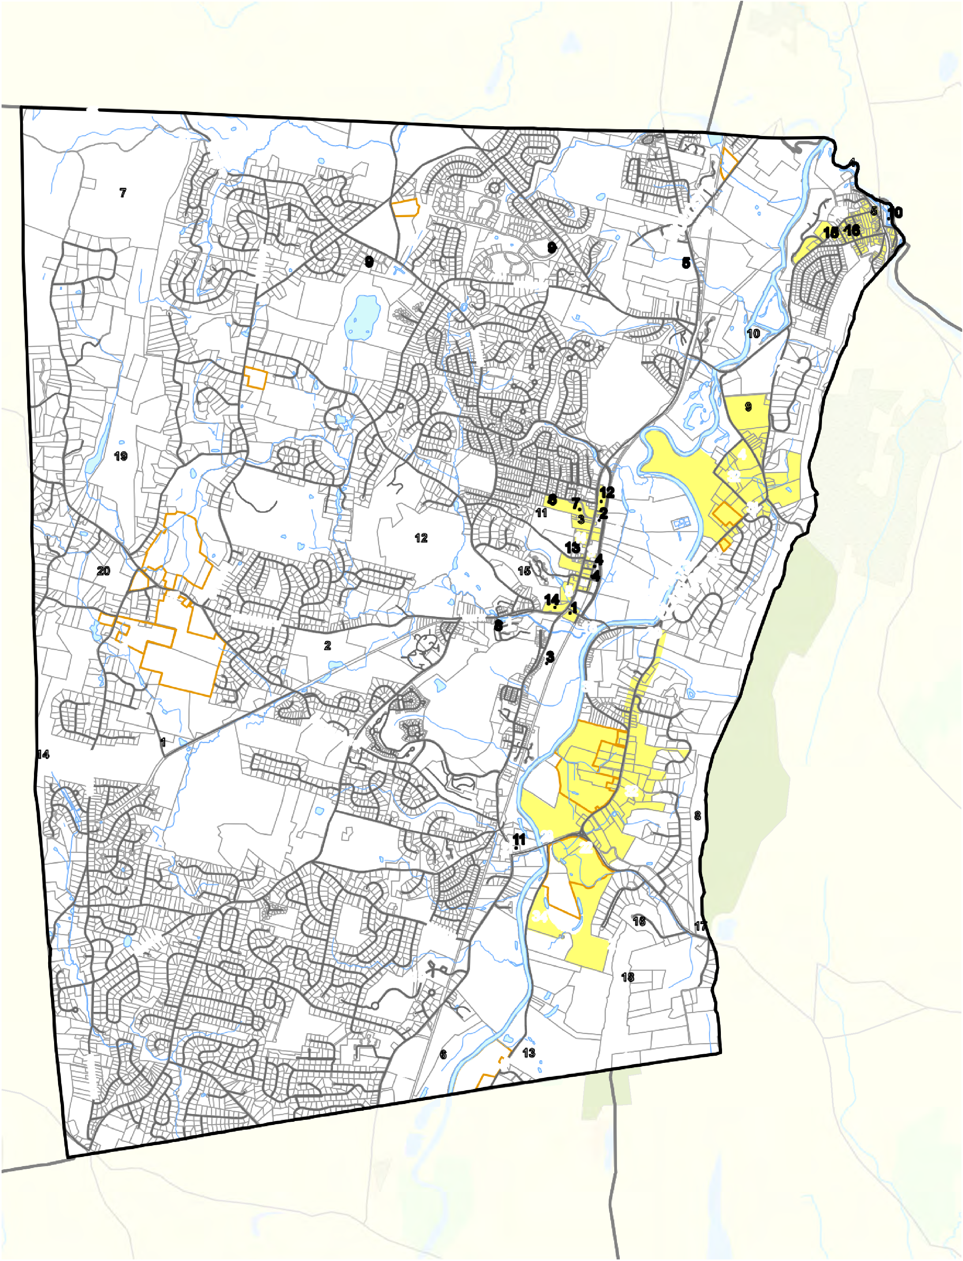

Canton

!(44

!(202

4,250

Feet

!(10

6 6 13

Avon
Character Building Historic District Stream Waterbody
- Buildings
- Aesthetic Places
- Farms
- Parks and Recreation

Simsbury recognizes that the aesthetic aspects of development affect the over‐ all ambience of our community and the quality of life of residents. If a development does not maintain or enhance community character in some meaningful way, it is actually detracting from community character in Simsbury.

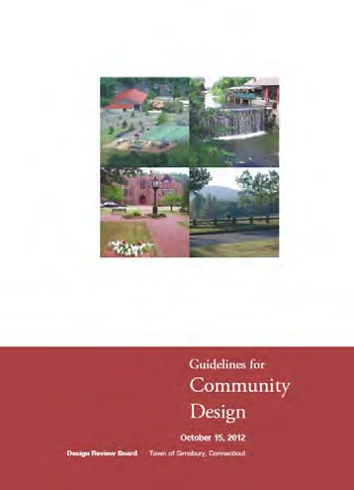
Simsbury has had a Design Review Board for many years and the work of this Board should continue to ensure that new development fits into the community well. The Board has promulgated award‐winning design guidelines that serve to guide its efforts and inform applicants of how to prepare applications.

The POCD takes the position that new development in Simsbury should maintain or enhance community character in some meaningful way. Design review is critical to maintain and enhancing community character and these efforts should continue and be strengthened as needed.

Community Design Guidelines

GOAL
Maintain and enhance the overall character of Simsbury by preserving and protecting the characteristics that contribute to its overall ambience and quality of life.

7.1 Identify and protect the resources, “sense of place”, and quality of life that contribute to the overall character of Simsbury.

A. NATURAL / CULTURAL RESOURCES –Simsbury will: | Leader | Partners
- Preserve significant natural resources that contribute to community character.  - Preserve stone walls, burial sites, cellar holes, and other cultural resources that contribute to community character.  □ a. Consider a Town ordinance to preserve stone walls.  - Use techniques such as open space cluster zoning and view sector regulations to preserve character resources. | Town | CWC
 | Town
 | BOS | CWC
 | ZC
 | Code legend is on inside back cover

B. COMMUNITY DESIGN –Simsbury will: | Leader | Partners
- Maintain and improve the design review process in Sims‐ bury to ensure new developments reflect, complement and enhance the overall character of Simsbury.  - a. Review and update the “Guidelines for Community Design.”  - b. Tailor the design guidelines, as needed, to village centers and other special places in the community.  - c. Investigate if there are ways to incorporate public comment into the design review process.  - d. Consider ways to incorporate dynamic computer visualization tools (such as Sketchup) into the de‐  sign review process so that all aspects of a pro‐ posed development are visualized and understood in the context of other buildings around them.  - Seek to ensure that new development complements, and is compatible with, the existing fabric of Simsbury and complements nearby historic structures and sites. | DRB
 | DRB
 | DRB
 | DRB
 | DRB
 | DRB
 | Code legend is on inside back cover

“Dark Skies”
C. NOISE / LIGHT POLLUTION –Simsbury will: | Leader | Partners
- Manage artificial lighting to maintain and enhance community character and help reduce light pollution.  - a. Incorporate “dark skies” principles into the zoning regulations in order to minimize negative impacts  of artificial lighting.  - Minimize impacts of noise on residential areas from commercial and industrial uses.  - a. Evaluate the regulatory issues associated with adoption of a noise ordinance. | ZC
 | ZC
 | BOS
 | BOS
 | Code legend is on inside back cover

The term “dark skies” is used to draw attention to light pollution and its impact upon night skies. More information is available from the International Dark Sky Association.

Several decades ago, there was little night lighting being used so its overall impact was not particularly noticeable. Nowadays, excessive night lighting is having an overall impact on communities and the quality of life. It also wastes electricity.
D. COMMUNITY SPIRIT –Simsbury will: | Leader | Partners
- Seek ways to maintain and enhance community pride and spirit.  - Encourage community and civic activities that promote and enhance community spirit.  - Support concerts at the Performing Arts Center, fireworks, local parades, and other community events.  - Maintain a community calendar to inform people of upcoming events.  - Collaborate with Simsbury Community Television and other media formats (print media, social media, email blasts, etc.) to keep residents informed about community affairs.  - Continue programs to recruit volunteers and recognize “hometown heroes” who have made a difference in the community. | Town Town Town Town Town  Town
 | Code legend is on inside back cover

A dark‐skies ordinance or regulation typically:
  - requires all outdoor light fixtures to shine downward only.
  - prohibits light streaming up into the night sky, where it interferes with a clear view.

Simsbury Fly‐In Simsbury Celebrates

Historic Places
7.2 Protect historic and archeologic resources and celebrate their contribution to community char‐ acter and sense of place.

The National Register of Historic Places (NRHP) identifies resources significant in the history of the nation. The State Register of Historic Places (SRHP) identifies re‐ sources significant in the history of the state.
A. OVERALL –Simsbury will: | Leader | Partners
1. Preserve and protect historic and archeologic resources since they contribute to Simsbury’s overall character and sense of place. | Town | HDC SHS
2. Maintain a Historic Resources Inventory in cooperation with the State Historic Preservation Officer (SHPO). | Town | HDC SHS
3. Use the Archeological Site Sensitivity Analysis of the Town of Simsbury to identify potential archeological sites. | Town
4. Seek to create corridors or linkages between historic sites when possible (for example, the Rosedale Farm ‐ East Weatogue Street ‐ Tariffville corridor). | Town | HDC SHS
 | Code legend is on inside back cover

These designations are not regulatory in nature and only directly affect activities involving federal and/or state funding. Property owners may be eligible for tax bene‐ fits for improvements to these resources.

The designations may be for districts (areas containing multiple properties) or for individual properties.
B. RECOGNITION –Simsbury will: | Leader | Partners
- Promote Simsbury’s historic sites, structures and districts.  - Promote heritage tourism in Simsbury as part of our commitment to being a Preserve America community.  - Increase public awareness of local historic resources through print / digital means (Town website, library, schools, etc.) and through other means.  - a. Recognize the presence of the remnants of the historic Farmington Canal in Simsbury by installing  signage and publicizing it.  - b. Consider enhancing the appearance of the Route 185 bridge by adding architectural lighting and  other enhancements.  - Support the listing of qualified buildings, sites, structures, and districts on the National Register of Historic Places and the State Register of Historic Places. | Town | HDC
 |  | SHS
 | Town | HDC
 |  | SHS
 | Town | HDC
 |  | SHS
 | Town | HDC
 |  | SHS
 | Town | HDC
 |  | SHS
 | Town | HDC
 |  | SHS
 | Code legend is on inside back cover

Local Historic Districts

A local historic district is regulatory in nature and a local Historic District Com‐ mission regulates exterior changes in view from a public street. A super‐majority of property owners must consent to the establishment of a local historic district.

A local historic property may be similarly protected or may be protected by ownership, easement, or other means consented to by the property owner.

Adaptive Re‐Use
C. PROTECTION / REGULATION –Simsbury will: | Leader | Partners
- Support efforts to protect historic sites and areas.  - Consider historic and archeologic resources as part of land use applications.  - a. Amend the Subdivision Regulations to require consideration of historic and archeologic resources.  - b. Amend the Zoning Regulations to require consideration of historic and archeologic resources and  preservation of such resources, where possible.  - c. Adopt regulations to protect archeological re‐ sources.  - Support the establishment of local historic districts (a regulatory approach) where supported by affected owners.  - Retain the Town’s Delay of Demolition Ordinance. | Town | HDC
 |  | SHS
 | Town | ZC
 |  | PC
 | PC
 | ZC
 | Town
 | Town
 | BOS
 | Code legend is on inside back cover

Since older buildings may outlive their original purposes, adaptive re‐use is a process where older buildings are adapted for new uses while retaining their historic features.

For example:
- an old factory may be‐
come an apartment building,
  - a church may become a
restaurant (or a
restau‐
restaurant may become a church),
  - an old house may be converted to office use.

D. ADAPTATION / RE‐USE –Simsbury will: | Leader | Partners
1. Consider allowing adaptive reuse of historic buildings (residential, commercial, governmental and industrial) if that will be instrumental in preserving them. | ZC
2. Maintain the architectural integrity of historic structures and sites when adapted for re‐use for commercial, industrial or residential purposes. | DRB | ZC HDC SHS
3. Encourage preservation of the historic character of structures and sites and the restoration / maintenance of such buildings in an appropriate way. | Town | HDC SHS
 | Code legend is on inside back cover

E. PROGRAMS –Simsbury will: | Leader | Partners
- Pursue and promote financial incentives for preservation (grants, tax incentives, loans, easements, assessment deferrals, etc.)  - Use techniques such as open space cluster zoning to pre‐ serve historic buildings and sites.  - Maintain Simsbury’s designation as a Certified Local Government in the National Historic Preservation Program in order to be eligible for grants and other assistance. | Town  Town Town | ZC PC  HDC
 | Code legend is on inside back cover

24 Granby
!
(

Historic Points and Places

1
!
(
!( 2

Tariffville Historic
O LC
WO
25 District
!
5
(

!30
189
((!
Simsbury, CT
East Granby $

(!309

!( 36

Simsbury Center Historic District
14
!(

21

39!(

9 !(!(28
49
20 !(
!(!
!((

4!(

38
!
(

47
32

!(202
!(202

37!(

8!(
!(

!(315
6!(

29
!
(
(!315

!( 33

!( ₃

(! !( !( 31

Terry's Plain

34
13!(
40
!(!((
!
48!( !(19
42
!
10 (

Historic District

46!(

49!(
(!309

15!(

!(167
11

!(10
41 !(
12

!(202
(!

23!(
7!(

East Weatogue Local Historic District

Bloomfield

Canton

!(167

43
W M O U N T A IN R D
!(
16
!
(!(
17

35!(
!(26

27
(
!
!(185

Legend

!(10
45
!
(

44!(

(!185
Historic Points
!( National Register of
Historic Places

(!167

!(10
22!(

East Weatogue NRHP District

18!(

!( Locally Important
Historic Districts
National Register Of Historic Places (Non- Regulatory)

!(44

!(202

Avon
Locally Important (Regulatory)

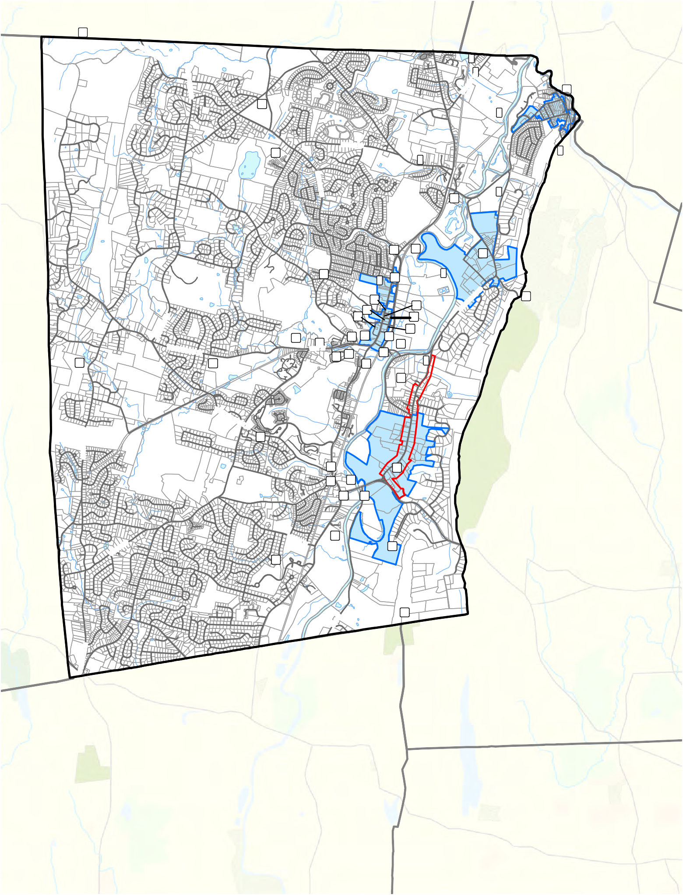

5,000

Feet
Site
- Town Farm Cemetery
- Stone Railroad Arch at Town Farm
- Bartlett Tower
- Cullman Brothers Inc. Dormitory
- Governor's Bridge Railroad Crossing
- Stone Quarry at Quarry Road
- Russell Marker
- Pent Road Ferry
- Horace Belden/ Central Schools - NRHP
- Old Drake Hill Bridge - NRHP
- Saw and Grist Mills at Hop Brook
- Canal Arches Over Hop Brook
- Cooper Smelter and Steel Mill
- Mindwell Adams Marker
- Jared Bradley Marker
- Civil War Monument
- White Memorial Fountain
- Heublein Tower - NRHP
- Cannon Medical Center - NRHP
- Eno Memorial Hall - NRHP
- Englewood (Simsbury 1820 Home) - NRHP
- Farmington Canal - NRHP
- John Humphrey House - NRHP
- Pilfershire Cider Mill
- First Fairground
- Manto Meadow
- Old Fuse Factory
- Militia Training Ground
- Militia Training Ground
- Carpet Company
- Central New England Station - NRHP
- New Haven and Northampton Station - NRHP
- Wintonbury Road
- Wire Mill
- 1734 Toll Bridge
- Cullman Brothers Inc. Plantation
- Bissell's Landing
- 1788 Bridge
- Probable Location of Potash Works
- Stone Quarry
- Calvin Barber Stone Quarry
- Ferry Site 1673
- Probable Location of Indian Fort
- King Phillip's Cave
- American Sumatra Tobacco Plantation
- Stoddard Reservoir 1907
- Simsbury Bank and Trust - NRHP
- Boy Scout Hall - NRHP
- Massaco Forest Pavilion - NRHP
- Phelps Tavern - NRHP

Major Farms
7.3 Support the preservation of working farms and the availability of farmland soils.

  - Tulmeadow Farm
  - Flamig Farm
  - George Hall Farm
  - Rosedale Farm
  - Pickin’ Patch
  - Town Farm
  - Folly Farm
A. WORKING LANDS – Simsbury will: | Leader | Partners
- Work with local farmers and others to identify specific mechanisms to preserve agricultural lands.  - a. Create an Agricultural Subcommittee to create a plan for farm preservation.  - Promote the use of agricultural “best management practices.”  - Lease Town‐owned agricultural land to farmers on a multi‐ year basis to encourage investment in the fertility of the land and promote farming uses on those lands.  - a. Survey existing Town‐owned open space to identify suitable parcels for additional agricultural use.  - Seek to provide incentives to preserve agricultural lands.  - Seek to provide incentives for reclaiming farmland that has fallen into disuse.  - Encourage the retention of quality agricultural land in agricultural use.  - Should such lands become available, give working farms and agricultural land high priority for “open space” acquisition or development rights acquisition.  - Use techniques such as open space cluster zoning and view sector regulations to help preserve working farms and help preserve prime or important agricultural soils that could be utilized for commercial farming or community gardens. | Town | AG
 | Town
 | Town | AG
 | BOS | AG
 | Town | AG
 | Town | AG
 | Town | AG
 | Town | AG
 | Town | AG
 | ZC | Town
 |  | AG
 | Code legend is on inside back cover

Other properties in Simsbury may also be farmed on a regular basis (including the former Culbro tobacco fields, fields in the Farmington River floodplain, and other areas).

Rosedale Farms
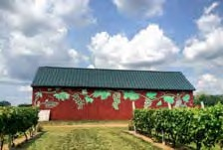

Tulmeadow Farm
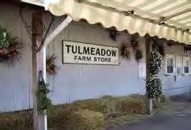

Flamig Farm
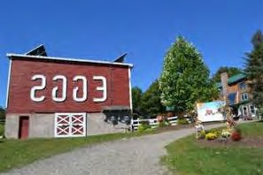

Town Farm
B. PRODUCE MARKETS ‐ Simsbury will: | Leader | Partners
- Encourage the formation of farming cooperatives to facilitate a mutually beneficial farming environment.  - Encourage the purchase of products (such as milk, wine, and produce) from local farms.  □ a. Strive to find a permanent location in Simsbury for a farmers market. | AG AG  AG
 | Code legend is on inside back cover

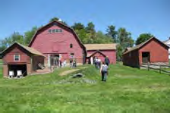

Granby

Agricultural Resources Map

10

(!202
East Granby

7

(!315

Simsbury, CT

!(189
$

!(315

3
(!202

(!309 4

1
9
1

2
2 (!309
1

(!167

!(202
W MOUNTAIN RD

!(167

!(10
5

(!185

Bloomfield

8
- Tulmeadow Farm
- Flamig Farm
- George Hall Farm
- Joseph Hall Farm
- Rosedale Farm
- Pickin' Patch
- Town Farm
- Folly Farm
- Ryan's Flower Farm
- Anthony's Farm

!(10

!(185

(!167

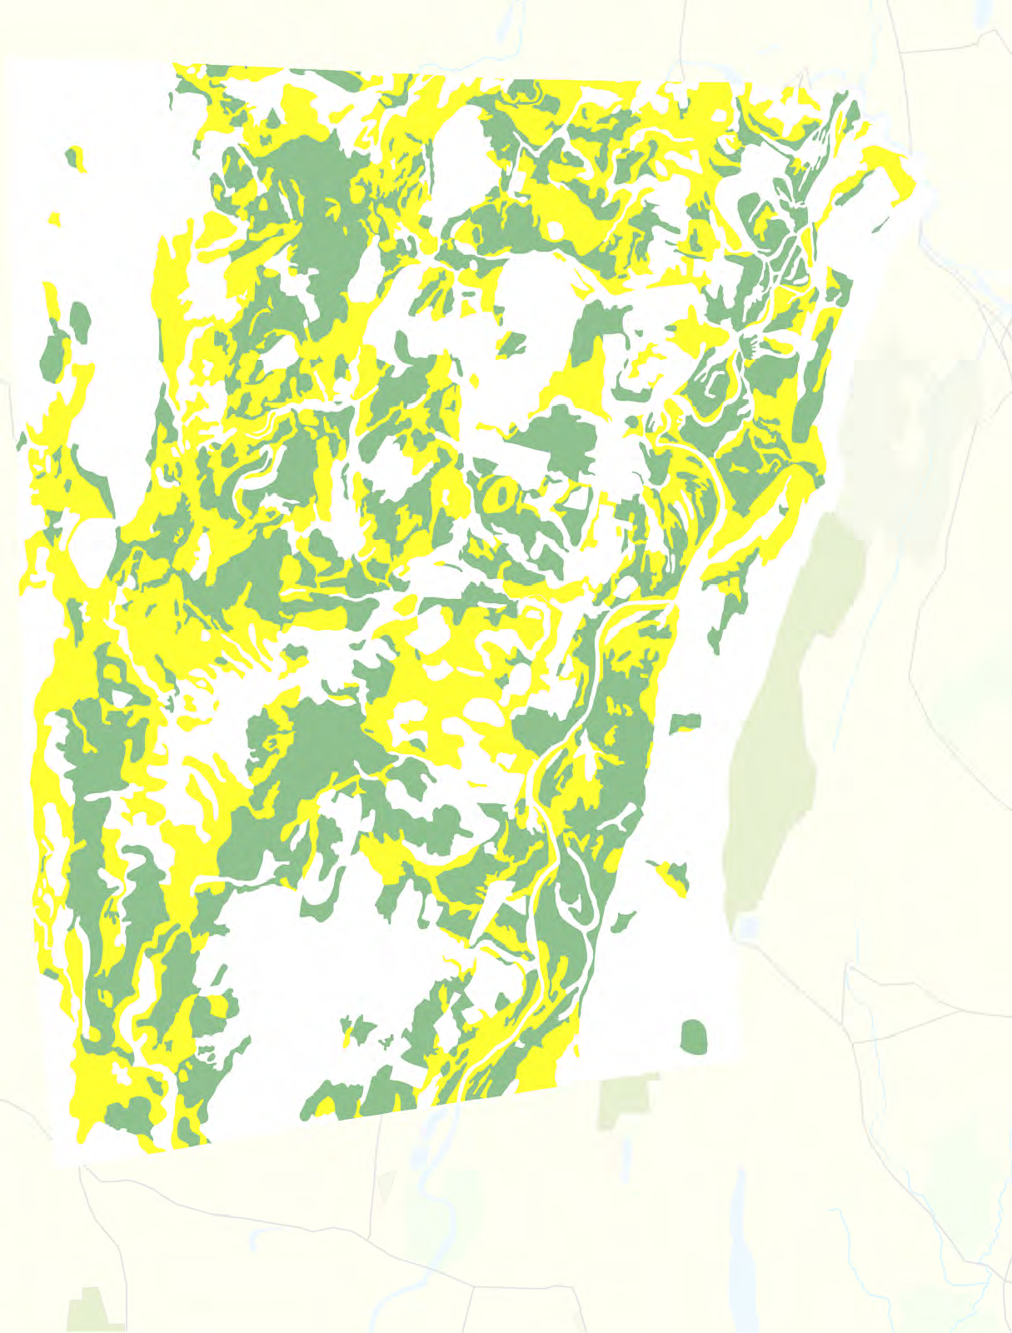
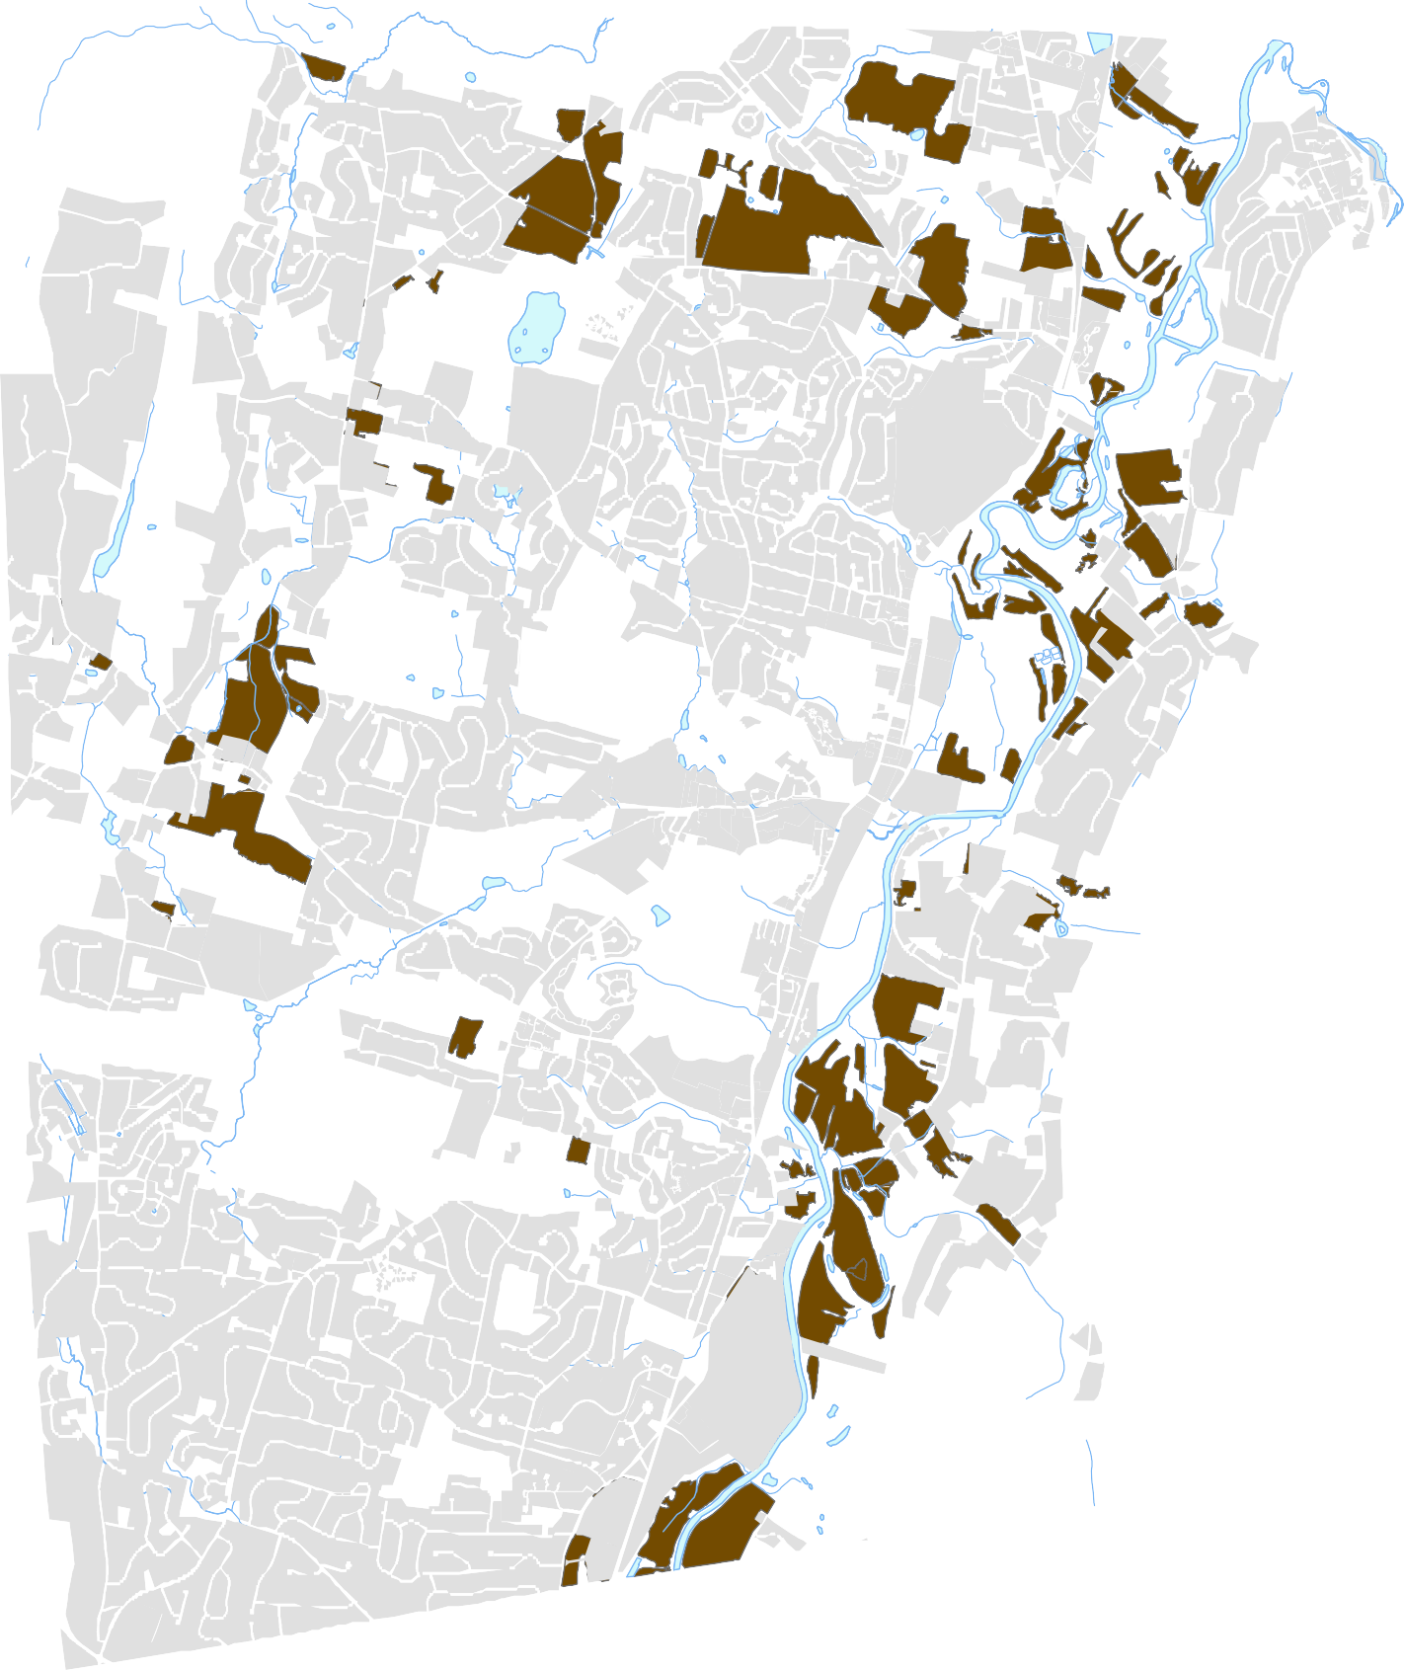
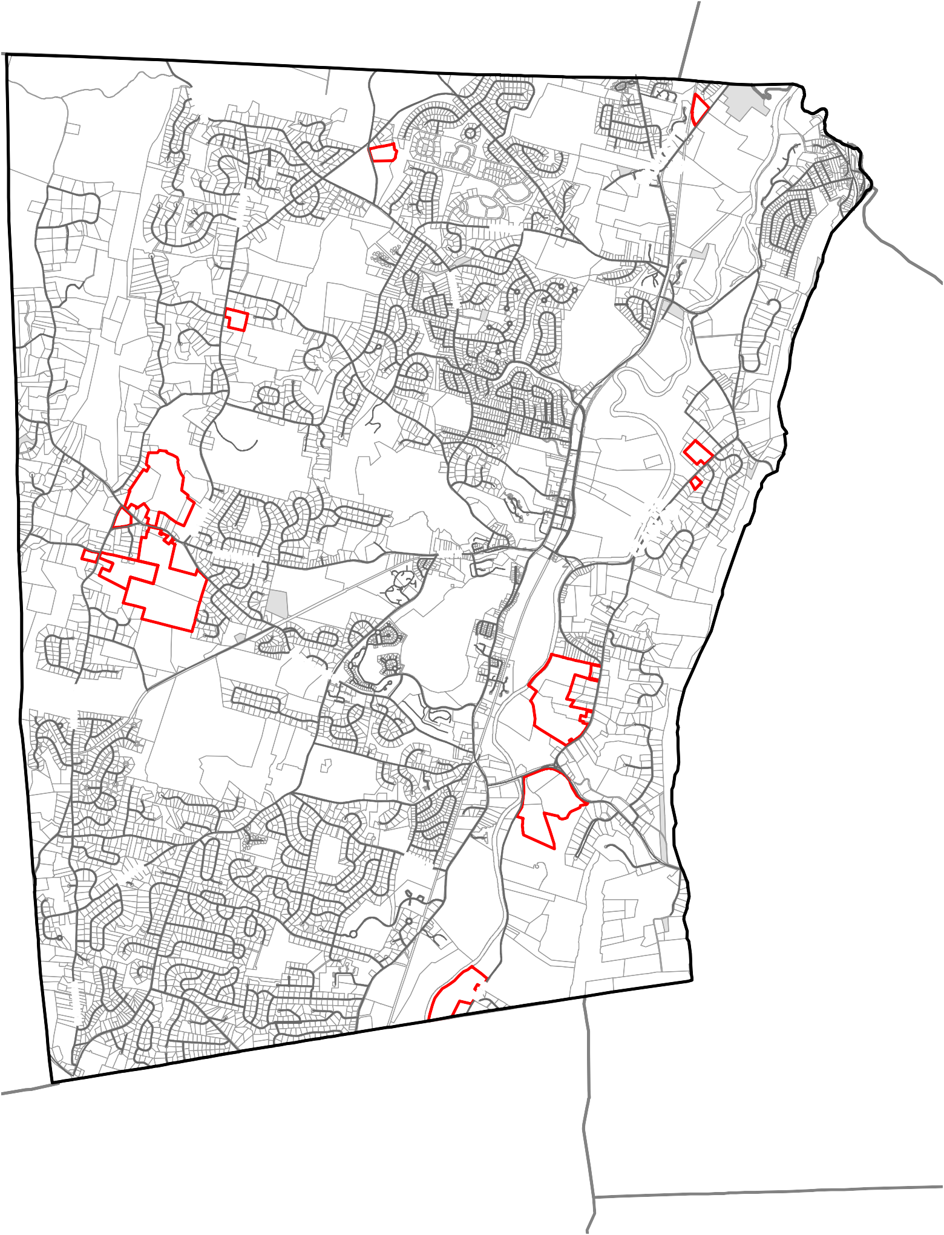

Canton

!(44

(!202

4,250

Feet

!(10

6

Avon

Legend
Major Farms
Areas Recently Farmed Developed Areas
Farmland
Prime Farmland Soils
Statewide Important Farmland Soils

Scenic Views / Vistas
7.4 Preserve and enhance the scenic characteristics of Simsbury.

- the Talcott and West Mountain hillsides and ridgelines;
- the Farmington River valley from the hillsides and ridgelines;
- the farm fields in West Simsbury;
A. SCENIC FEATURES –Simsbury will: | Leader | Partners
- Preserve scenic resources that enhance the overall character of Simsbury (partial list in the sidebar on this page and in the beginning of Chapter 7).  - a. Amend the Zoning Regulations to strengthen pro‐ tection of scenic resources.  - b. Amend the Subdivision Regulations to strengthen protection of scenic resources.  - Maintain the Scenic Road Ordinance and designate additional scenic roads, where appropriate.  - Collaborate with the Simsbury Land Trust and similar organizations promoting preservation of scenic resources.  - As opportunities arise, seek to put wire utilities under‐ ground in Simsbury Center and other village centers in or‐ der to enhance community character. | Town | SBC
 | ZC
 | PC
 | Town
 | Town | SLT SBC
 | Town
 | Code legend is on inside back cover

- the Ethel Walker hillside and fields along Bushy Hill Road;
- vistas that embody the rural characteristics of Simsbury, such as those along Nod Road, East Weatogue Street and Terry’s Plain Road; the southerly portion of Old Farms Road; the inter‐ section of Laurel Lane and Great Pond Road; vistas of the Farmington River; the Tariffville Gorge; and other vistas.

Scenic Road Ordinance

Simsbury’s Scenic Road Ordinance allows the Planning Commission to designate scenic roads in Simsbury, after receiving consent of the owners of a majority of lot frontage along the road.
B. RIDGELINES / HILLSIDES –Simsbury will: | Leader | Partners
1. Establish, maintain and enforce regulations to protect hillsides and ridgelines and the scenic views to and from these areas. | Town | ZC PC
 | Code legend is on inside back cover

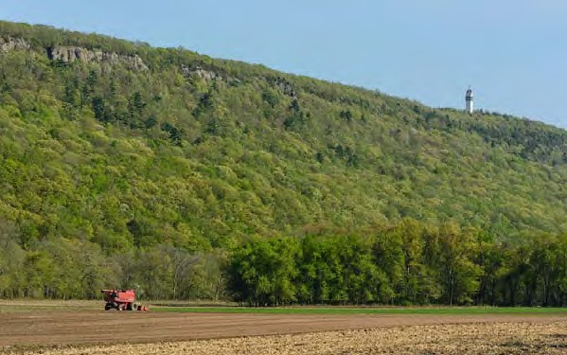
Such designation helps protect that roadway from inappropriate changes.
Fields
Hillside
(side of the hill)
Ridgeline
(top of the hill)

The following Town roads have been designated since the establishment of the ordinance:
- Goodrich Road
- Ferry Lane
- Terry’s Plain Road
- East Weatogue Street
- Barn Door Hills Road

Currently there is no state highway within Simsbury designated as a Scenic Road.

Granby

Scenic Resources Map

Simsbury, CT

!(202

(!202

(!315

!(315
!
!
!
!

!(189
$
East Granby

!(309
!

!
!

(!167

!(309

!_{!(}167
!

!(167

!(10

!(10

!(202
W M O U N T A IN R D

(!185

!
!
!
(!185 !
!

!
!

Bloomfield

!

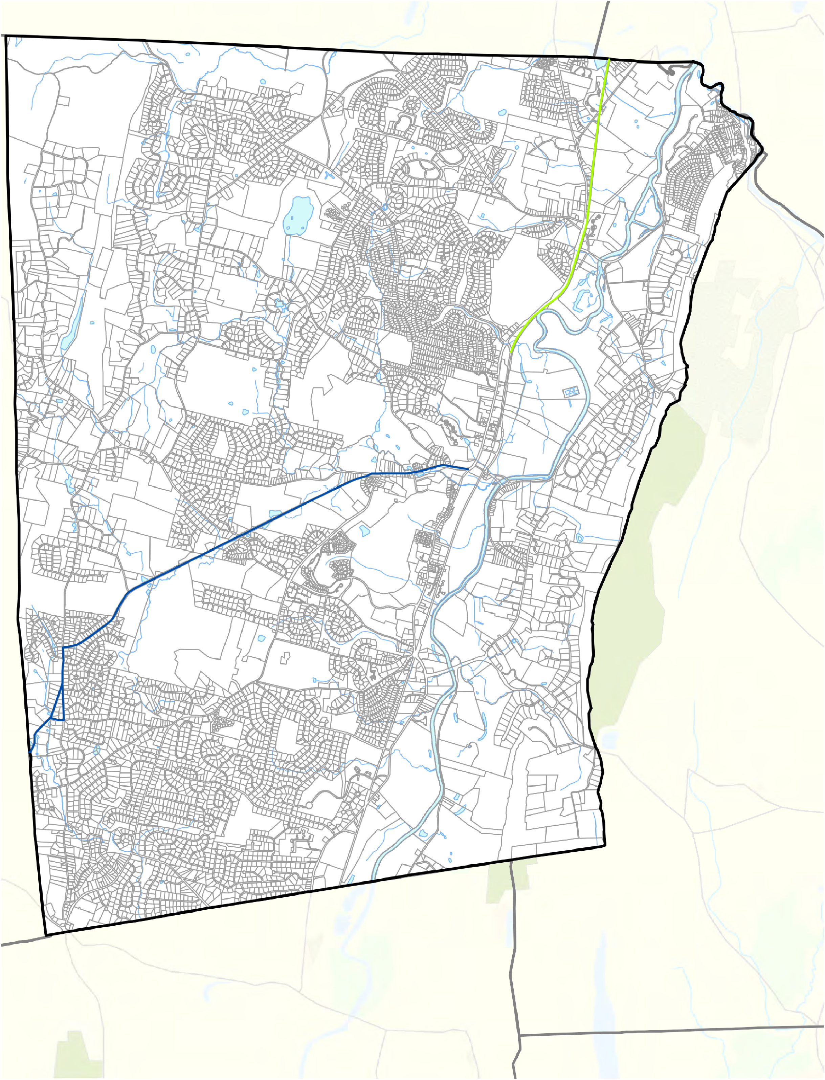
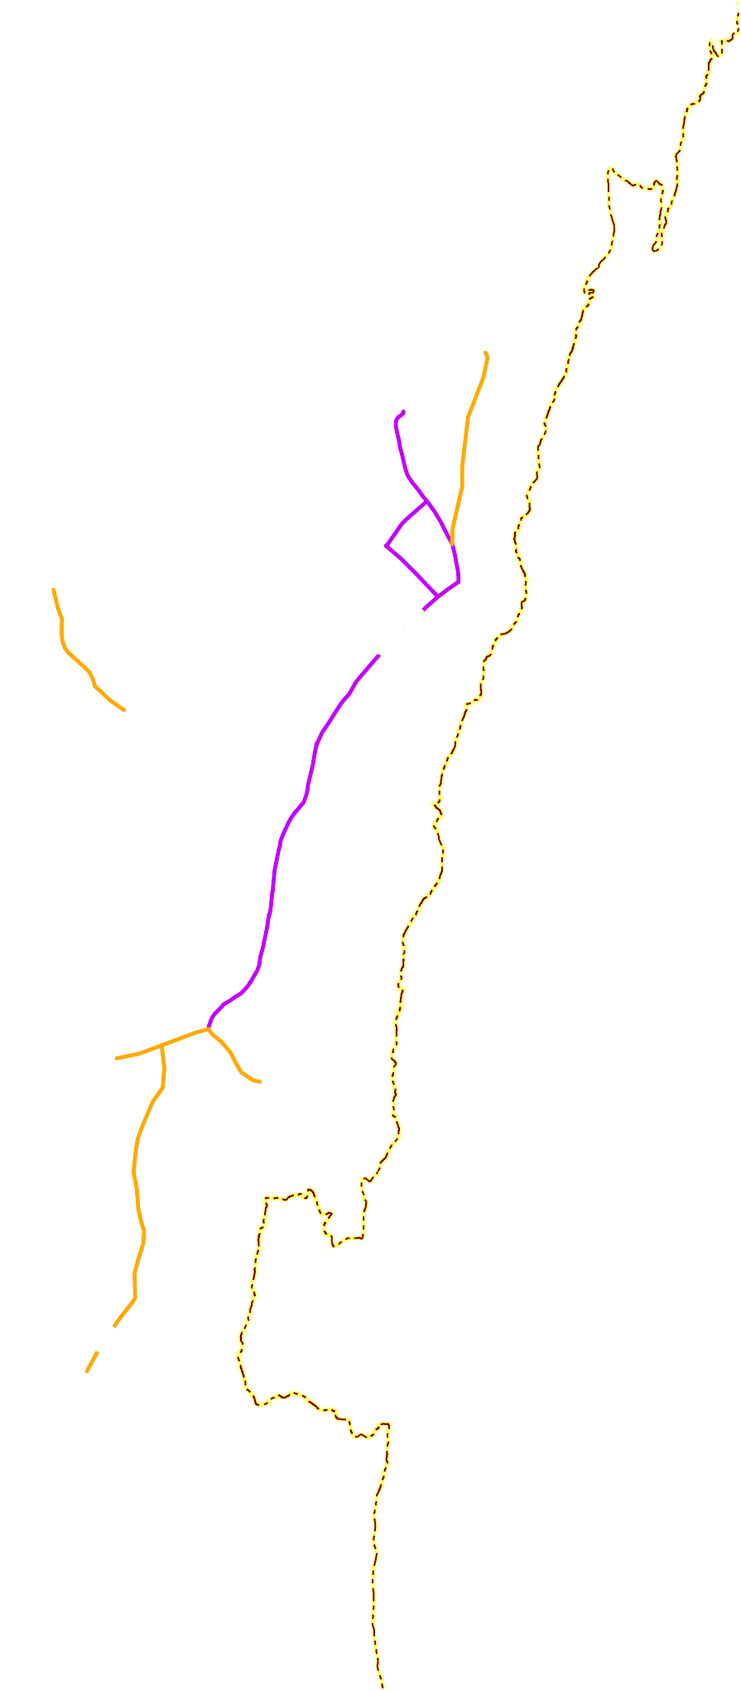

Canton

!(44

(!202

4,250

Feet
!(10

Avon

Legend
Metacomet Trail
! Views of Ridges / Hillsides / Heublein Tower
! Other Scenic Views
Locally Designated Scenic Road Other Scenic Road
Farmington Valley Greenway Farmington River Trail

PA‐490 Program
C. UNDEVELOPED LAND –Simsbury will: | Leader | Partners
1. Continue to use the “PA‐490” assessment reduction pro‐ gram (CGS 12‐107) to help preserve undeveloped land as long as possible.  □ a. Review the criteria for the PA‐490 “open space” assessment category to evaluate whether to ex‐  tend incentives to residentially‐zoned parcels less than 25 acres in size. | Town  Town | BOS PC
 | Code legend is on inside back cover

The PA‐490 program (codified in CGS Section 12‐107) is an assessment reduction program that reduces taxes on certain types of land so that it is more likely to re‐ main undeveloped.

The 2016 Grand List reports the following:
- 84 parcels used for farming (totaling 1,419 acres),
D. TREES / VEGETATION –Simsbury will: | Leader | Partners
- Recognize the importance of trees and vegetation to Simsbury’s overall character and environmental health.  - a. Develop a comprehensive program for streetscape improvements along major streets.  - Preserve and maintain historic and significant trees such as the sycamores along Route 10 and Route 185.  - a. Develop a maintenance / replacement plan for street trees, (especially the iconic sycamore trees  along Hopmeadow Street in Simsbury Center).  - Emphasize the importance of landscaping (including berms) as part of any commercial development.  - a. Amend the Zoning Regulations to include a section outlining landscaping requirements. | Town | SBC
 | Town | PW
 | Town
 | Town
 | ZC
 | ZC
 | Code legend is on inside back cover

- 12 parcels of at least 25 acres kept as forest (totaling 861 acres),
- 12 parcels meeting the open space criteria (totaling 576 acres).

Gateway Approaches

The following locations could be considered as major gateways in Simsbury:
- The north and south entrance points of Route 10/202
- The intersection of Routes 167 and 44
- The intersection of Routes 315 and 189 in Tariffville
E. GATEWAYS –Simsbury will: | Leader | Partners
- Seek to preserve and enhance the major “gateway” approaches to and within Simsbury (see sidebar).  - Encourage the preservation of existing woodlands along the streetscapes, such as but not limited to Routes 185 and 309, to enhance the character of the gateway.  - Through the site plan review process and other means, maximize landscaping and minimize pavement on public and private right‐of‐ways at the gateway approaches. | Town Town  Town | ZC PC
 | Code legend is on inside back cover

- The entrances at Route
185, Nod Road and Route 309
- The Wolcott Road area near East Granby
- The entrance points on the Farmington Canal Heritage Trail and other trails

Gateway Sign
