Date: July 8, 2021

To: Simsbury Planning Commission

From: Michael Glidden CFM CZEO
Director of Planning and Community Development

Re: Referral from Board of Selectmen concerning release of conservation easements associated with the Meadowood Subdivision

Summary of Referral

As part of the Resubdivision approval, the existing conservation easements need to be release in order to complete the transaction.

The Board of Selectmen referred the release of the easements pursuant to Connecticut General Statutes 8-24 to the Planning Commission for review and comments as it relates to the goals and objectives from the 2017 Plan of Conservation and Development.

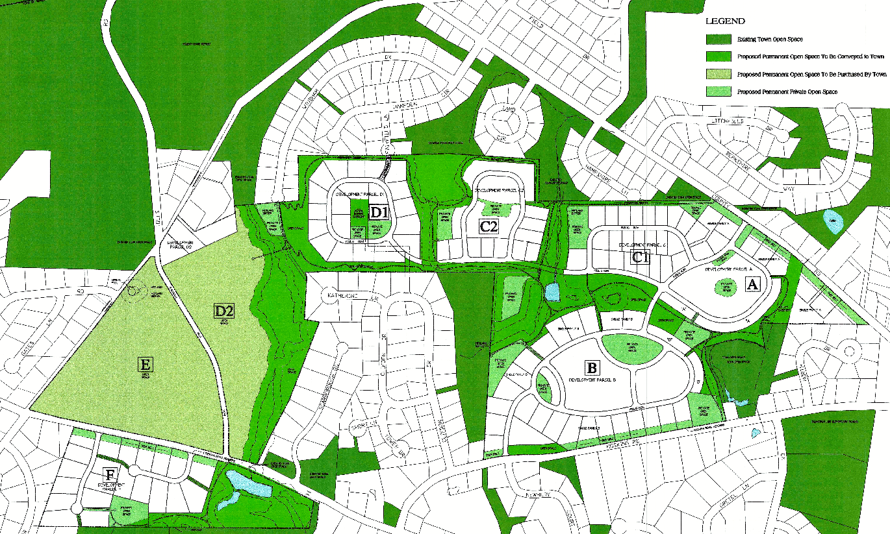

The role of the commission is to provide an advisory opinion on whether the proposed actions meet the goals and objectives from the 2017 Plan of Conservation and Development.

One point to consider is the release from the easements is required in order for the state funding to be approved. In the end, a larger portion of the development will be preserved beyond the limits of the existing conservation easements.

Another point is the area which will be funded by Department of Agriculture monies will require that the area is farmed. Efforts will be made in order to lease the fields associated with this parcel to local farmers for agriculture activities. This could be considered preservation of existing agricultural fields that otherwise would have been lost to residential development.

