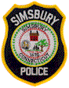
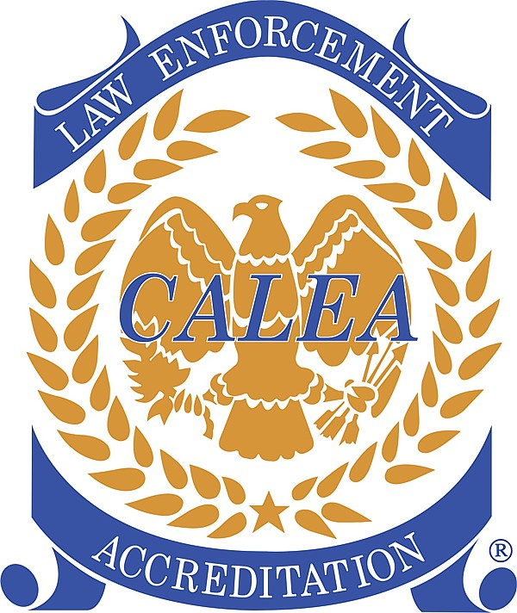
Simsbury Police Department

“In Partnership With Our Community”

TELEPHONE SCAM ALERT

June 16, 2017

The Simsbury Police Department has been made aware of a telephone scam that is occurring throughout the community. The individuals are contacting residents and pretending to be selling medical equipment. They are also trying to deceive residents into believing that they have won a trip or a free stay at the Marriott Hotel.

The scammers are using a program to make the calling phone number appear as Town of Simsbury telephone numbers (860) 658-3141 and (860) 658-3143. They may try to contact you using different Town of Simsbury numbers as well. These individuals are attempting to gain personal information and credit card information.

Visit our website by clicking the link below to find more information on how to protect yourself from scams.

https://www.simsbury-ct.gov/police-emergency/pages/scams

If you believe you have been a victim of a scam and/or have any questions, call or visit the Simsbury Police Department (860) 658-3100.

